Stages Of Evolution

Introduction:

Welcome to the Stages Of Evolution. This video is going to break down each level of growing an agency to multi 7-figures from the challenges you’ll face, how to solve them, and the profit margins & team structure of each level.

This module will also break down how to graduate from one level to the next and how to scale past multi 6-figures / month in your agency if you wish to do so.

Before I dive into each stage of the agency, you must understand 5 things:

- What Problem This Solves
- The Problem Solution Cycle
- Problem Solving Archetypes
- The Decision Making Bias
- New Level New Devil

If I just give you the practical answers without first giving you the thought processes, the market will shift, things will change, and you’ll have no clue how to re-calibrate

'Give a man a fish and you feed him for a day. Teach him how to fish and you feed him for a lifetime'

What Problem This Solves⛔️
Imagine being in a maze wearing a blindfold that only lets you see one step ahead. You're feeling your way forward, with no clue if you're approaching a dead end or the exit.

This is how the majority of business owners operate - making decisions based only on what's immediately visible, with no perspective on the bigger picture. They are making decisions on impulse and letting the fires that pop up throughout the day dictate what they focus on.
Now imagine someone lifts your blindfold and lets you see the entire maze from above. You can immediately spot all the dead ends, identify the shortcuts, and map the most efficient route to the exit.

That's the goal of this module... to give you clarity on what stage of the maze you’re in, how to advance to the next stage, and all the shit that’ll come up along the way (and how to deal with it)

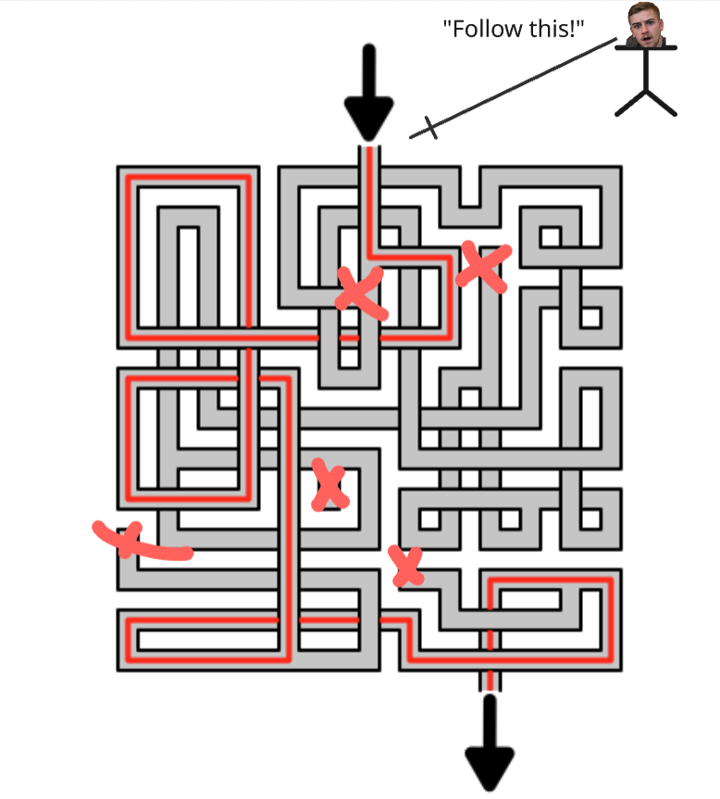
And if I can scale from $0 - $250k in MRR in 2.5 years without this roadmap in one of the hardest niches there is (which has a million mini niches within it)
you should be able to do it much quicker, with much less pain than I had to face.
And (I hope) we’re aligned on this being the reason you paid me money to join this program.
To help you solve problems you don’t know how to solve, want help solving, and to identify future problems you don’t know are there yet (the unknown unknowns)

The Problem Solution Cycle🔄
"Businesses are just effective problem-solving machines."
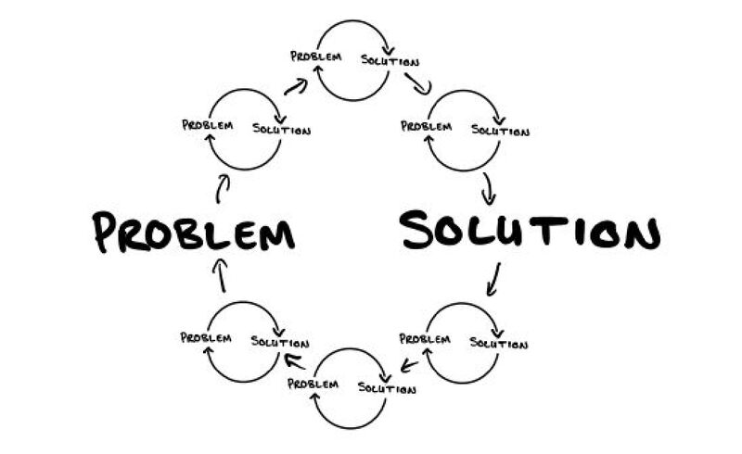
Most people have a belief that problems are “bad/negative” - no matter what business you run, one thing I can guarantee you is problems are going to be there. And once you solve one problem, you’ll have another…

This is what we refer to as the “problem solution cycle” - and I tell you this because you and your agency need to be an effective problem solving machine.

The one thing that's stopping you from being at $100k/mo is you haven't yet solved the problems that allow you to make that amount of money

Here’s a practical example of a “chain of cycles” that correlates to the agency space:

Cycle 1:
- Problem: Nobody is interested in your services
- Solution: You start running paid ads and get a shit ton of leads
- New problem: Your calendar is full but your close rate is terrible (you cant sell)
Cycle 2:
- Problem: You can’t close
- Solution: Go through sales trainings, get your calls reviewed and start tracking sales metrics
- New problem: You are spending all your time onboarding and managing clients
Cycle 3:
- Problem: You're overwhelmed doing all the client work yourself
- Solution: You hire your first VA to handle onboarding and client tasks
- New problem: The VA makes mistakes and you spend more time fixing their work than doing it yourself
Cycle 4:
- Problem: You have no SOP’s or structure in your fulfilment
- Solution: You re-structure your onboarding and fulfilment and SOP the entire process
- New problem: Your VA wants a raise because she’s taken on more responsibilities than she used to
The takeaway here is that problems never end - they just evolve. Your job as an agency owner isn't to eliminate all problems (that's impossible) - but to develop the skills, systems, and mindset to solve increasingly complex problems effectively. You need to be a problem solving machine…
The most successful agency owners I know aren't the ones with the fewest problems - they're the ones who've become masters at solving problems quickly and efficiently.
And being aware of this cycle benefits you tremendously: because your clients have their own infinite number of problems too → which if you're aware of them, will allow you to create strategic upsells to solve future problems for your clients and make more money from them.
That's literally what I'm doing in this program right now: I know that after I help you hit 6-figures/month, you're going to face a new set of challenges. You'll either want to:
- Turn your agency into a cash-flowing asset that only requires 3-4 hours of your time per week
- Build systems that make your business sellable for an exit
By solving your current problems on the front end (in this program), it becomes a no-brainer for you to continue working with me to solve these future high-level problems too.

Problem Solving Archetypes🧬🔨
So now we’ve covered why being a problem solving machine is important, how do you make decisions on how to solve the problem effectively?

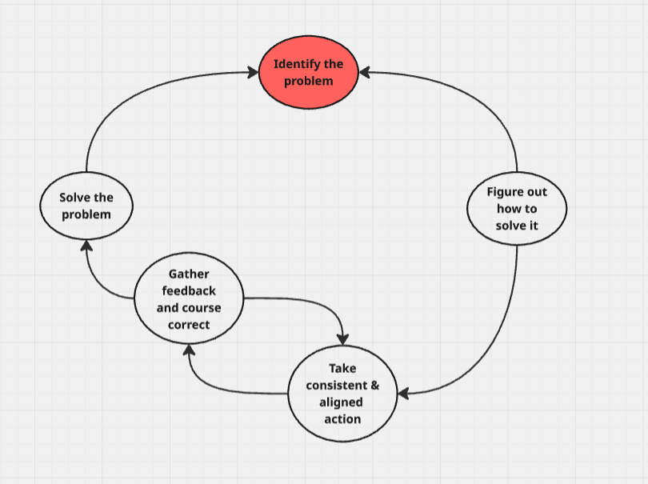
The Problem Solving Feedback Loop

Your success directly correlates with how quickly you can go through this loop
And you’re using this right now, every single day, you’re just not aware of it - this is what happens when you solve a problem

When you face a problem in the feedback stage, sometimes it makes sense to take a step back and even take a revenue hit for long term gain. Think of it like a mountain climber who descends to find a better route when faced with a cliff too steep to climb.
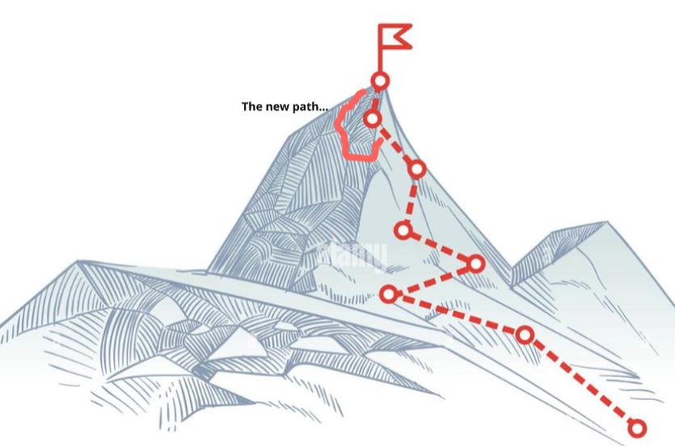

They could exert all their energy trying to climb up the steepest part of the hill, or they could be patient in the short term, climb back down some parts of the mountain to find an easier part to climb and approach it at a new angle.

A prime example of this was in September of 2023 when I scaled super fast and hit $90k in one month. My ego was telling me to keep pushing sales as hard as possible so I could post that fancy Stripe screenshot on my story and get the external validation that comes with it, even though I would’ve (and did) churn a bunch of people the next month.
So I made the decision to take an ego hit, scale back down to $30k-$50k so I could rebuild all our systems - and it was the best thing I ever did, because 3-4 months later I then had the foundation to scale quickly without increasing churn and everything breaking on the backend.
That "failure" took me higher than my original route ever could have.
Key Lesson: There are going to be times when it makes sense to take a step back in order to take 5 steps forward - You can’t build a skyscraper on the foundations of a two-story house…

The Foundation =
- Team
- Systems
- SOP’s

The better of a foundation you build below the surface, the quicker you will grow once it’s built. The reason it’s so difficult is because it doesn’t feed your ego at the level showing your new cash month and how quickly you scaled your agency.
Learn from my mistakes…

The Decision Making Bias🧠 ⚖️
So you might be asking “Cameron, I get how to solve problems, but how do I know which decisions I should spend a ton of time on making, and which ones to make quickly?”

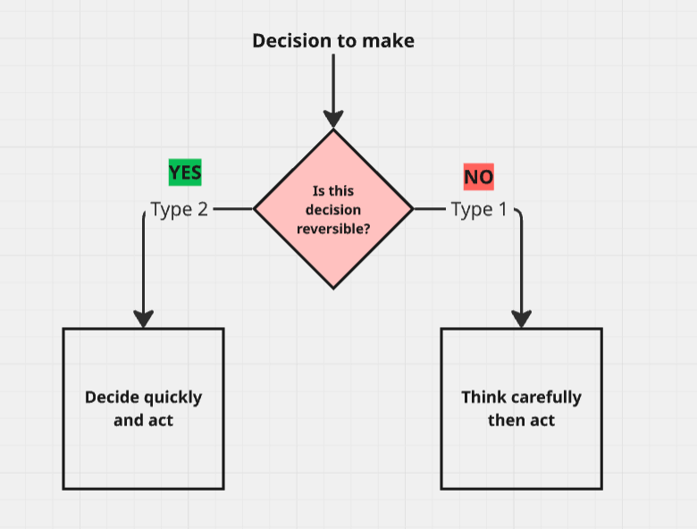
There’s 2 different decision types

Type 1 decisions are irreversible and high-impact - these deserve careful consideration as they are “one way doors” (once you walk through you can’t walk back…)

Type 2 decisions are reversible and low-impact - these should be made quickly and these are “two way doors”

Examples of Type 1 (One-Way Door) Decisions:
- Bringing on a 50/50 partner - Bringing on a partner who will have as much decision making power as you, and have a large % of your profit every month
- Making a major tech stack migration - Moving your entire client base from one platform to another (like switching from ClickFunnels to GoHighLevel for all clients) - these tools are intentionally made to be sticky and chances are all your SOP’s are based on your old tool
How to Handle Type 1 Decisions:
- Slow down deliberately - Take days or weeks if necessary → Do what I call a “think tank” session and just sit and journal for an hour or two and listen to what your gut tells you
- Gather multiple perspectives - Get input from mentors, team members, people you look up to… → I have a list of people I always ask for advice that I can go to in situations like this - take their advice with a grain of salt as it’s all contextual on if and how the decision you make benefits them directly
- Create decision documents - Write out the pros, cons, and reasoning - ask AI → I consult with AI on every big decision i need to make and even have a life therapist ChatGPT agent I do it with who I’ve trained to be as no bullshit as possible
- Sleep on it - Give your subconscious time to process
Examples of Type 2 (Two-Way Door) Decisions:
- Launching paid ads / doubling your ad spend - if it doesn’t work out just turn them off you wont die
- Hiring a VA - Easy to part ways if it's not a good fit
- Trying a new project management tool - You can always switch back or try something else
- Raising your prices for new clients - You can always adjust them again if you get pushback
- Implementing a new client onboarding process - Easy to revert if it doesn't improve client satisfaction / time to launch
- Outsourcing a specific responsibility in fulfilment - You can bring it back in-house if quality suffers
How to Handle Type 2 Decisions:
- Make them quickly - Often within minutes or hours
- Delegate them deep in the organization - Let team members make these calls
  - Set clear parameters - "If it costs less than $X, just decide"
- Establish a bias toward action - "When in doubt, try it out"

How to Identify Which Type of Decision You're Facing:
Ask yourself the following:
- Reversibility: Can I undo this decision relatively easily?
  - If yes → Type 2
  - If no → Type 1
- Cost of reversal: How expensive (time/money) would it be to change course?
  - Low cost → Type 2
  - High cost → Type 1
- Impact scope: How many parts of the business would be affected?
  - Limited impact → Type 2
  - Widespread impact → Type 1
- Time horizon: How long will we live with the consequences?
  - Short-term → Type 2
  - Long-term → Type 1
- Optionality: Does this decision open or close future options?
  - Opens options → Type 2
  - Closes options → Type 1
I make type 2 decisions extremely fast and my team can often get pissed at me for it - Rule of thumb is act and iterate quickly, and you’ll make significantly more progress than the people who spend 5 days matching the colours on their landing page to their ads… focus on the 80/20 and always ask:
How much of an impact does this have on business growth, retention, and net profit?
Most decisions in your agency (probably 90%+) are Type 2. Treat them accordingly and you'll move much faster than your competition.

New Level New Devil😈
Each revenue milestone ($5k, $15k, $30k, $60k, $100k+) is a new level with its own unique devil you’ll need to slay. What got you here won't get you there. You'll need new team members, new skills, and a higher pain tolerance at each level.
Scaling is exactly like a video game. If you restart, it's easy to get back up to the level you reached before. But reaching the next level - one you haven’t achieved yet - is a new challenge with a new devil to conquer.
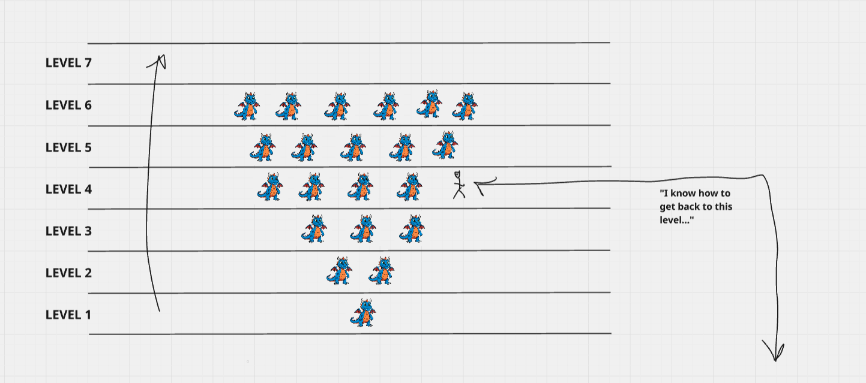
The team that gets you to 6 figures wont get you to 7 - there’s going to be lots of hard conversations with people, you will have to fire people even though they might be the perfect culture fit, the skill deficit is so big it’s not worth training them to the new standard of talent required.
Side Note: Once you've conquered a level, your personal standard changes. I won't accept making less than $100k profit in a month anymore because it makes me feel sick - it's below the personal standard my identity holds.
Just think about how much money you make now, and what is the bare minimum you would accept yourself to make → Chances are the number you have in mind is significantly different than if I asked you that question 5 years ago.

That's the power of shaping a new identity: your personal standard wont allow you to make any less (let this be a prime example of how everything you want can be found internally)
You can think of it like going to the gym and lifting weights. Lets say you want to hit a new personal best on bench press, and the most you’ve benched is 95kg and you want to get up to 100kg
When you progressively overload - you’re pushing yourself past the point you believe your muscles are capable of - you create RESSISTANCE, which in turn, tears the muscle fibers and makes them stronger
And with enough willingness to face the resistance/pain/uncomfortability of pushing the weight up, you will (with time) hit your goal of an 100kg bench press
Business is the exact same - at each new level there is a new challenge you’re going to face that is going to suck - and the only way past it is through.
Inevitable Fuckery
You can do all the training in the world before the fight, but when you’re in the ring it’s a different story. As mike tyson says “everyone has a plan until they get punched in the face”
An example of this was in February of last year when my CSM unexpectedly quit with no notice, tried poaching all our clients and taking our best team members to start her own Medspa agency.
We had a 33% churn month and went down from $100k in revenue in January down to $33k in February.
Shit will happen that is unexpected.
You will be punched in the face, and it’s hard to prepare for it, but one frame I put on situations like this that served me immensely was that it was all in divine timing: the universe wanted me to learn a lesson and follow a new path I couldn’t yet see → and I can tell you from experience that on reflection, I wouldn't change a thing about what happened even in the worst periods of growing the agency - the hardest part is putting your ego aside and being patient, but if you can do it you’ll beat all the kids out there building the agency for a stripe screenshot so they can sell coaching.
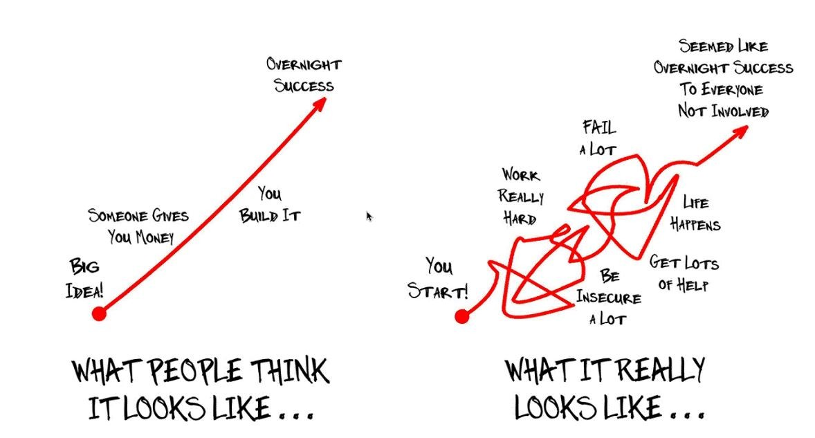
When that CSM did churn, I went back into client success for 3-4 months and realized:
- I had no replacement for her and needed to dial in my hiring process
- I had no SOP’s to train and ramp someone up quickly because I manually taught her everything
- We had no client success systems and our onboarding process was an absolute shitshow
So in the grand scheme of things, it was the best thing that could have ever happened - because now we have incredible SOP’s, an abundance of candidates to hire for every single position, and dialled in client success systems.
I'm preparing you for this because I wish I had this expectation going in. It would've helped a lot → most people sell you on this linear A-Z success path and it’s bullshit. “Embrace the suck” and know it’s happening to serve you.
Final thing to keep in mind when growing fast:
- Don’t get too attached to your current crazy high profit margins: At scale, your margin will get smaller, but you will also buy back more of your time by hiring people to replace you in the low leverage activities in the business and eventually even the high leverage ones. You do not have to continue to grow if you don’t want to, but from my personal opinion, I’d rather have an agency doing $100k/mo with 50% profit margins and working 1-2 hrs/day than an agency doing $50k at 80% margin where I do everything and work 10hrs/day. It takes longer, but it’s so worth it.

Stages Of Evolution🧬📈

At this point you should understand what to expect when growing your agency, how to solve problems effectively, and the unexpected things that may come up along the way.

Within this section I’m going to break down every level of the agency from $0 to $250k+/month and beyond.

At each level I’m going to break down:

- How to know if you’re here: Not everything is going to be EXACT (there is going to be something you’re ahead on, and others you’re behind on, but the premise is you should at least resonate with the constraints at that level and have some similarities)
- Unit economics: This is a breakdown of the revenue structure, expenses, and org chart
- Common Pitfalls: The biggest & most common challenges at this level
- Solutions to those constraints

01: Skill Stack Phase
- How to know if you're here:
  - Revenue between $0-$10k/month
  - Just picked a niche and trying to get product-market fit
  - Have fewer than 5 clients, mostly on performance models or free trials
- Unit Economics:
- Revenue Structure:
  - 1-5 clients at $500-$1,000/month average retainer value
  - Often performance-based or majority are free trials
- Cost Structure:
  - You're doing everything yourself (0 team cost)
  - Overhead: $200-$500 / mo (basic stack such as GHL, Zapier…)
  - Profit margin: 90%+ (artificially high because you're not paying yourself)
- Org Chart: Solo operator wearing all hats
- Common Pitfalls:
  - Feeling scared that you can't sign clients because you "don't know how to deliver"
  - Coming into SMMA with the misconception that you can start signing $2K/month retainers with no effort
  - Focusing too much on fulfillment and binge watching gurus all day instead of taking action
- How to Solve These Problems:
- Focus on the first part of the funnel: Outreach and sales (SACA)
  - If you have the cash flow to invest in ads ($1500/mo minimum) then get started with that immediately as it will save you a ton of time - if you don’t → implement the SMS blast cold outbound process to start getting more appointments and closing more deals
    - Cold SMS Outbound Process
- Build a pitch deck to sell prospects on sales calls
  - How To Pitch
- Sign clients on a pay-on-results basis to earn while you learn
  - I’m not a fan of “free trials” - best way to do this IMO is to get paid when you book the clients appointments (tie it to something you directly control
    - Ex: When I started out, I’d call my medspa clients leads and take a $50 deposit when I booked someone and that went directly to me → You should go into this phase with the intention of learning as much as humanly possible about fulfilment not to make a boat load of money: you’re in your “skill stacking” phase
      - Pay Per Lead Models
- Bend over backwards to get your small client base results and do everything possible → once they get results, request a video testimonial and get one client to commit to being a “strategic partner” which you can use as leverage in your sales process so you can begin to charge upfront
  - Social Proof SOP - follow this SOP for reference
- Develop your offer/guarantee once you have confidence in delivery & have 1-2 testimonials under your belt to charge upfront
  - Offer & Guarantees Module
- Resources to Implement:
- Module: Offer & Guarantee Creation
- Module: Lead Generation & Nurture
- Module: Sales
- How To Know You’ve Graduated
  - 3+ clients on retainer → Built out your offer/guarantee and transitioned from pay on results to a retainer and signed a few clients on the retainer model
  - 1-2 Client testimonials
  - 1 referral partner who speaks to “on the fence” prospects if needed

02: Delegation Dilemma
- How to know if you're here:
  - Revenue between $10k-$20k/month
  - Have between 5-10 clients
  - Feeling super overwhelmed and doing 99% of the work yourself
  - Understanding your market better, dialing in cold outreach, solid understanding on how to onboard and fulfill clients
  - You have $5-$10K+ saved up in a cash reserve
- Unit Economics:
- Revenue Structure:
  - 5-10 clients at $1,000 / month average retainer (may be higher)
  - Fully moved to standardized retainer model and transitioned commission only clients or let them go
  - Just selling month to month commitments and you have a few clients paying you a retainer every month who have renewed
- Cost Structure:
  - First VA: $500-$800 / mo (likely part-time or project-based initially)
  - Overhead: $500-$1k / mo (expanding stack with project management tools such as Slack, Loom…)
  - Profit margin: 80-90% (still artificially high because you're doing a lot of the work)
- Org Structure: You
  - + 1 VA (Wearing a “black hat” and doing all low leverage tasks you previously did such as onboarding clients, managing their ads…)
- Common Pitfalls
- You have clients running ads for a bunch of different services or in different niches and its getting hard to create a “one size fits all” solution
- Cold outreach isn't signing you as many clients as you want, and is sucking up a shit ton of your time
- Holding back on running paid ads because you’re scared to sacrifice some profit
- You know how to sell people on a commission model, but have a limiting belief around taking payments over the phone and don't know how / get super nervous every time you pitch an upfront payment so you offer a free-trial
- Overwhelmed with work and in order to scale need someone else to help (not enough hours in the day as you're doing cold outreach, selling, onboarding, managing client ads, communicating with clients…)
  - This is where you need to learn how to hire your first VA to delegate the lowest leverage tasks, you can hire them part time - full time on $500 - $800 / month
- How to Solve These Problems:
- Get Crystal Clear on WHO you serve and WHO you don’t
  - Niche Clarity & Research
- Pricing: move to 3-month contract Paid in fulls on the front end
  - This allows you to go from collecting $1k-$2k upfront to charging $3k-$6k upfront which will give you more immediate cash that you can reinvest into paid ads and scale
    - Price Drop & Objections
- Lead flow: Start running paid ads on a small scale: broad ads, static images, $30-$100 per day, depending on the cash you have saved up to a general lead form, build out a B2B sub account in Go High Level and dial leads as soon as they opt-in to book them in for a sales call - the process:
  - Paid Ads Speed Run Video
  - Dialling Leads Live Breakdown
- Sales: Build out your sales framework and improve your pitch deck (add case studies and refine USP’s now you understand the market better)
  - Demo Call Process
- Hiring: Hire your first VA to help you with client admin and management tasks
  - Pay Structure: $500 - $800 / mo for full time
    - You get what you pay for → if you have cash flow to invest I’d go for someone around the $1k mark as the skill gap is HUGE
  - How To Hire Your First VA
- SOP Creation & Delegation: Map out the lowest leverage things that take up the majority of your time, chances are it's: Onboarding clients (tech), setting up ads, managing ads etc. Record a LOOM video of you doing the process from A-Z, then break it down into a step by step in google docs: Demonstrate, duplicate, delegate
  - Time Management Audit Process
  - Creating SOPs & Structure
- Resources To Implement
  - Lead Generation & Nurture module (focus on paid ads)
  - Operations & AI module (focus on SOPs)
  - How To Hire Your First VA
  - Sales Crash Course
- How To Know You've Graduated:
  - Consistent lead flow from paid ads (4+ leads per day)
  - First VA handling 20+ hours of work weekly and saving you time on low level tasks
  - Documented SOPs for at least 3 core processes
  - Closing at 20%+ on sales calls with an upfront payment
    - Sold your first PAID IN FULL
  - Collecting 40%+ cash upfront on all new clients

03: Scaling Shitshow
- How to know if you're here:
  - Revenue between $20k-$40k/month
  - Have 1-2 VAs on your team
  - Running paid ads to get clients and have successfully signed 5+ clients from paid ads
  - Growing pretty fast but managing your clients and the operations side of your business is a shit show
  - Struggling with churn issues because your product is kinda shit and considering becoming a guru
  - Clients are complaining that they are not getting as much support and attention as they used to and may get their first bad review or client that leaves on bad standing
- Unit Economics:
  - Revenue Structure:
    - 15-25 clients at $1,500-$2,500/month average
    - Moved to 3-month contracts with 50%+ paid upfront avg
    - Starting to implement performance components to increase average client value (commission on outcomes)
  - Cost Structure: Org Chart
    - 1-2 VAs: $1k-$1.6k / mo (now full-time dedicated)
    - 1 Media Buyer: $800-$1k / mo
    - 1 Setter: $1.5-$2.5k / mo
    - First CSM: $3k-$5k / mo (first significant hire)
    - Overhead: $2k-$3k /mo (expanding tech stack with client reporting tools)
    - Profit margin: 50-60% (leans down as you grow because you overhire to set yourself up for scale)
      - P&L Examples At Each Stage
  - If hiring call center: 1 agent for every 10 clients (depending on lead flow)
- Common Pitfalls:
  - Getting lots of unqualified leads coming in and wasting calendar space with no-shows and tire-kickers
  - You physically can not handle all client communication as well as taking sales calls - your calendar is crazy (or its getting to a point of being a problem)
  - Client fulfilment is getting difficult to manage & clients begin to churn at a higher rate because you cant give them as much personalized support/communication as they used to have
  - You don’t have any tracking systems for each department of the business and do not understand what your core KPIs are and how to track them
- How to Solve These Problems:
- Recalibrating Your Focus:
  - Map out your Org Chart & P&L structure
  - If you have a call center: Tweak pricing structure to increase avg retainer value
    - this hybrid pricing model is printing me an extra $1.3m this year
- Sales & Marketing: Hire a setter and consider moving to a 2-call sales process so the setter qualifies the leads, then you take the qualified demo calls:
  - PPS - Setter Scorecard 2025
  - 1 call or 2-call process breakdown
  - Also add more qualification to your funnel on the front end to get more of your "ideal client"
    - How To Increase Lead Quality
- Client success: Hire your first client success manager on $3 - $5k / mo (you get what you pay for) - and begin building out a "bootcamp" to ramp them up → keep in mind here you are hiring EARLY and profit will take a hit, but you’ll thank me later when you make WAY more money because you have this person in place sooner rather than too late when you’re back to back on client calls and can’t do anything else (I’ve been there it’s not fun…)
  - Hire on INDEED or pay a recruitment agency & once hired train them up like you would a sales team
    - My Entire SOP Library - Look for the CSM Bootcamp
    - Managing & Training your CS Team
  - Start SOP'ing your Client Journey and Onboarding Process
    - The Client Journey
- Operations & Automations: Move all client management to a project management tool like Monday to manage client communication. Setup all the “Sales Systems” such as the “new client processes” & other key automations like notifying you of when a client needs a check in call, when a clients performance is below KPI…
  - New Client Automations
  - Onboarding Flow
  - Client Management System
- Standardize your fulfilment: Standardize fulfilment so everything can be similar between clients (funnels, ads, automations…) - Create a GHL snapshot that can be automatically copied in onboarding
  - Client Snapshot
- Client Churn:
  - Put the retention tracker tracker in place - Tracking Dashboard
  - Offboarding system in place & tracking / auditing why clients churn
- Resources To Implement
  - Client Success module
  - Service Delivery module
  - Operations & AI module (focus on project management)
  - Lead Generation & Nurture module (go through it all and dial everything in)
- How To Know You've Graduated:
  - Setter hired with 80%+ show rate on demo calls - you only speak to QUALIFIED prospects (90% of the time)
  - CSM handling 50-70%+ of client communication - handed off majority of clients to them
  - Standardized fulfillment process for all clients (ad templates and clear onboarding process that is the same for all clients)
  - Project management system to manage clients at scale
  - Churn rate below 15% monthly

04: Founders Friction
- How to know if you're here:
  - Revenue between $40K-$80K/month
  - Profit margin getting smaller because you're having to hire a bigger team
  - Team may be around 5-10 people at this point, if you have a call center maybe even more (15 ish…)
  - You do not have time to sell new prospects and need to hire a sales rep → not enough time to push big projects forward in “deep work”
    - You are the constraint of the business
- Unit Economics:
  - Revenue Structure:
    - 20-40 clients at $1,500-$3,000/month average retainer
    - Retainer + performance model fully implemented
    - Consistently collecting $20k+/mo in new cash from paid ads (or signing 7+ clients/mo from ads)
- Cost Structure: Org Chart Breakdown
  - Team costs: $20,000-$35,000/ mo
    - 1 CSM: $3.5k - $5.5k /mo
    - 1 Setter: $3k (base + commission)
    - 1 Sales Rep: $4k-$10k/ mo (commission only)
    - 1 Onboarding / Tech VA: $800-$1.2k/ mo
    - 1 Operations Wizard VA: $1.2k - $2k/ mo
    - 1-2 Media Buyers: $1k - $2k/ mo
  - Overhead: $5,000-$8,000/month (full tech stack now implemented)
  - Profit margin: 45-60%
  - P&L Examples At Each Stage
- Common Pitfalls
  - YOU are the biggest constraint in the business - spending too much time doing everything especially sales and can’t focus on moving big projects forward or managing the team at the level they need
  - Your hiring process is taking too much time and you have B-C players on your team you're afraid to let go of because you do not have enough candidates to replace them
  - You feel like you're in slack 10hrs/day answering the same basic questions and fixing fires not pushing the needle forward in the business
  - Ramping up new team members feels like you're repeating yourself with the same answers to the same questions and it takes so much time to ramp someone up
  - You're scared the key players on your team are going to leave because culture is kinda nonexistent and you don't really know how to lead properly
  - Managing the team is getting hard and its almost impossible to keep in the loop with what they are doing and if they are being productive or just jerking off all day
- How to Solve These Problems:
  - Sales Team Development: Hire your first commission-only sales rep to take sales calls (yes, they will and can be better than you, this is a limiting belief if you think otherwise) - you need to build out a sales rep bootcamp to ramp them up
    - Sales Rep Scorecard
    - My Entire SOP Library - Look for the sales rep bootcamp
  - Sales Systems: Implement a sales management system with daily meetings, call reviews, and performance tracking & learn how to manage/lead a sales team
    - Sales Systems To Build
    - Sales Team Management
  - Hiring & Team Building: Create a hiring pipeline in Go High Level, and create application forms for each key position with a mini VHL (Video Hiring Letter) on them so you can keep the hiring machine on at all times
    - Hiring Modules
  - Knowledge Management & Team Support: Create standardized SOPs for the most common client problems and scenarios that come up, and make text/email templates the CSMs and team can use to send to clients
    - CS Ticketing System
    - Client Slack Communication / CSM Slack Communication Guide - Text Templates
  - Move all SOPs to Skool and make bootcamps for key positions you hire for frequently to make the ramp up quicker
    - Ex: CSR’s, CSM’s, Media Buyers, Setters, Closers…
    - [Skool Bootcamp Template]
  - Culture & Leadership Development: Implement monthly meetings setting projections for the company, develop your core values, develop a big enough vision for the A players to fit their vision inside of the vision (Create buy-in)
    - Team Management & Leadership Modules
  - Team Management & Accountability: Implement EOD report, FFTs, and EOW report system to keep a gauge on what's actually being done - Also START thinking about who you could potentially promote into a team lead to manage the media / call center department (or fulfilment as a whole)
    - Go through entire team management module
  - Create department-specific KPIs and dashboards and assign DAI’s to each KPI
    - [Department KPI Dashboard]
- Resources to Implement:
  - Management & Leadership module (complete all sections)
- Hiring & Firing module (focus on sales reps and department heads)
- Operations & AI module (focus on team management and automation)
- How To Know You’ve Graduated
  - Sales team closing 20%+ of calls without your involvement
- Hiring pipeline with 3+ qualified candidates for each key position
- Team members resolving 50% (ish) + of issues without your input
- Clear reporting structure with daily/weekly visibility
- Core values and vision clearly articulated and embraced by team
- You're spending less than 10 hours per week on operational issues (ops wizard is now handling it)

05: Team Lead Transition
- How to know if you're here:
  - Revenue between $80K-$150K/month
  - 40-80 clients
  - Everything is broken and you find yourself spending so much time hiring for the same positions (Media Buyers, Tech People, CSR’s…)
  - It's getting increasingly difficult to try and manage your team because there's too many people
  - You feel like everything needs to be run through you in order for it to get done and you feel the need to micromanage
    - Team conflict may have also started to arise between team members
  - You have hit a new level of operational complexity and everything feels broken - it's getting harder and harder to manage all your clients while keeping churn low (churn may be at an all time high here and mistakes are much more frequent in onboarding and management tasks for clients)
    - Some common errors that may be happening: Typos on ads, custom values not filled correctly, using the wrong ads for one client which was meant for another…
- Unit Economics:
- Revenue Structure:
  - 40-80 clients at $2,000-$3,000/month average
  - Core service + upsells becoming significant
  - Consistently collecting $40k+/mo in new cash from paid ads
- Cost Structure: Org Chart - Start creating “pod” structure
  - Team costs: $25,000-$40,000/month
    - 1-2 CSMs: $8k - $10k/ mo
    - 1-2 Sales Rep: $5k-$10k/ mo (commission)
    - 1 Setter: $2.5k-$4k/ mo (base + commission)
    - 2 Onboarding / Tech VAs: $1.6k - $3.2k / mo
    - 1 Operations Wizard VA: $1.5k - $2k/ mo
    - 2 Media Buyers: $1.6k - $2.4k/ mo
    - Personal Assistant: $1k - $1.6k/ mo
    - Project Manager: $1.5k - $2k/ mo
    - Media team lead: $3k-$4k/ mo
    - If you have a call center
      - Hire a call center manager / promote someone within ($3.5k-$5k/mo)
  - Profit margin: 40-50%
    - P&L Examples At Each Stage
- Common Pitfalls
  - Key team members may have unexpectedly churned (sales reps, client success)
  - The team task board is a mess and it's very difficult to stay organized - deadlines consistently being missed
  - Your client success manager is too busy and is feeling overwhelmed
    - Only applies if they have 40+ clients - if below this its an inefficiency issue not a capacity problem
  - You do not have the time to check in on every team member all the time even though everyone is coming to you to solve problems
  - Churn is going up as a result of you growing fast
  - Communication breakdowns between departments
  - Lack of clear leadership structure below you (most people come to you directly)
  - If you’ve scaled ads you may start getting disproportionate returns (Way lower ROI)
- How to Solve These Problems:
  - Team Culture & Retention: Improve culture with weekly team culture calls and bi-weekly 1-1's with key team members
    - [Team Culture Development Framework]
    - Implement “Culture Building” activities and systems
  - Departmental Structure: Separate team task boards by department (Media, Tech, Client Success, Billing, Operations)
    - [Department Task Board Setup]
  - Create clear communication channels between departments and initiate the process of “Decentralization”
    - Communication Cycle
  - Pod System Implementation:
    - Organize team into PODS (mini business units that handle specific client segments) → Pod Breakdown - L&S - calculate baseline expenses and profit per pod
    - Promote top performers to team leads OR hire the team lead if no one is worth promoting (or the thing you hate doing the most / aren't good at / don't want to spend time on)
      - Ex: for me this was media buying and the call center
  - Implement weekly department head meetings
    - Develop department-specific KPIs and reporting and assign KPI responsibility for departments to the team leads
  - Hiring Systems
    - Develop baseline capacities for each pod to give yourself & the team clarity on exactly who & when to hire in advance to prevent team capacity constraints
      - Ex: For every 40 clients we need a new CSM + media buyer, so when we hit 30 new clients on top of our current load we’ll start to hire…
    - Also hire another CSM if your current CSM is handling 40-50 clients
    - Hire & Train a project manager to manage deadlines, client payments, and be your main point of communication to keep things organized + running smoothly (Decentralization)
  - Churn Reduction:
    - Implement weekly churn audit call w/ the entire team to audit churn reasons
      - Auditing & Reducing Client Churn
      - Execute on action items decided that correlate with the most frequent churn reasons
    - Implement monthly NPS surveys going out to clients to get feedback
    - Implement client health scoring system if you haven't done so already
      - Health Scoring System
  - Disproportionate Returns on Ads:
    - Develop the skill of “diagnosing constraints” in your acquisition process
- How To Know You've Graduated:
  - Pod system fully implemented with team leads managing day-to-day operations
  - Team lead(s) managing entire departments with little involvement from yourself
  - Clear communication cycles that prevent most issues from reaching you
  - You're spending 80%+ of your time on strategic initiatives rather than day to day fires
  - Client health scoring system proactively identifying at-risk clients
  - Cross-departmental projects completing on time without your direct involvement
  - Team culture strong enough that A-players are referring other A-players to join

06: Decentralization
The beauty of reaching this stage is that you now have options. You've built a real business that generates significant profit and doesn't depend entirely on you. You can choose to keep growing, optimize for lifestyle, or prepare for an exit - the choice is yours.

- How to know if you're here:
  - Revenue between $150K-$250K+/month
  - 80-150+ clients
  - You have at least 1 closers and 1 setter that sell without you
  - You have 2+ client success managers and you are removed from client success
  - You have a pod system where there are business units within the business
  - You're spending most of your time on strategy rather than operations
  - You're at a decision point about the future direction of your agency
- Unit Economics:
  - Revenue Structure:
    - 80-150+ clients at $2,000-$4,000/month average
    - Multiple service tiers and upsells fully implemented (SEO, Google Ads…)
      - Backend offers increasing LTV significantly
    - Consistently collecting $30k-$100k+/mo in new cash from paid ads monthly
- Cost Structure: Org Chart
  - Team costs:
    - Full departmental structure with team leads
    - Sales team: $8k-$15k/ mo
    - Client Success team: $10k - $20k/ mo
    - Operations team: $10k/ mo
    - Media team: $5k-$10k/ mo
  - Overhead: $15,000-$20,000/month
  - Profit margin: 40-50% (optimized for founder removal)
  - P&L Examples At Each Stage
- Common Pitfalls
  - Churn - this is usually due to not treating your CS team like a sales team and not enough training
  - Growth slows down because if you churn at 10% with 100 clients you churn 10 clients a month - sales must ramp up and ad spend must increase a lot if you wanna keep going
  - Market saturation in your primary niche (depending on market size)
  - Maintaining quality and culture at scale (you’re essentially a therapist)
  - Developing executive leadership below you
  - Deciding on the future direction of the business
- Strategic Options:
  - Option 1: Scale What You've Got
    - Develop more pods for your core service offering and repeat the pod creation process
  - What is a pod - Rinse & Repeat
- Increase ad spend and grow the sales team
- Horizontally scale into niches with identical/similar fulfillment systems
  - Ex: I was in medspa, and branched out into pain management & ketamine therapy
- Keep growing and repeat the process up to $500k-$1M/mo (Org Example)
  - Option 2: Optimize for Profit & Time Freedom
    - Lean down operations and focus on maximizing profit margins (50%+) - you can do this at any stage just to be clear, but if you want to make a significant amount of money and be as minimally involved as possible this is the time to do it
      - I horizontally scaled into new niches and realized I no longer wanted to do it, and personally opted for this option: this doesn't mean you don't need to do anything with your time (which you totally can) →you can use it to build something you’re truly passionate about / want to do
    - Best way to do this is hiring an ops manager / COO who can run and manage the business FOR YOU
  - Option 3: Sell The Agency
    - You can consider exiting the agency, the avg value is 3-3.4x EBIDTA as of right now in 2025 (Yearly net profit)
    - This is an option I also considered, but agencies aren't the best thing to sell, it’s not like a SAAS where you can get a 10-20x EBITDA → and there’s a ton of variables to keep in mind when it comes to selling, your SOP’s need to be dialled in, churn needs to be low, and there can not be any “keyman risk”
- How To Know You've Graduated:
  - You've made a clear decision about the future direction of your agency
  - If scaling: Multiple pods operating independently with their own P&Ls
  - If optimizing: Business runs profitably with 5-10 hours of your time weekly
  - If selling: Business is structured for maximum valuation
  - You're spending 90%+ of your time on activities aligned with your chosen path
  - You have clarity and peace about your decision

